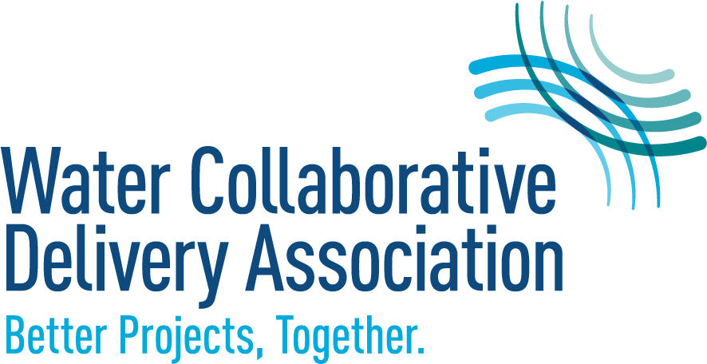

WCDA Code of Conduct
Approved September 2025

Water Collaborative Delivery Association (WCDA) is committed to creating a safe, professional, and inclusive environment for all members, member representatives, event participants, volunteers, and staff. Accordingly, all such WCDA constituents are expected to uphold the highest standards of professional integrity and conduct in connection with WCDA activities in order to allow WCDA to fulfill its mission of advancing collaborative delivery methods to transform the water industry through thought leadership and education, supported by research.

Agreement to this Code of Conduct is demonstrated by becoming a member, renewing membership, accepting appointment as a member representative, attending an event, volunteering for an activity, or entering a services contract with WCDA.

Member Code of Conduct

- Hold paramount the safety, health, and welfare of the public and all participants in their collaborative and design-build projects.
- Regularly promote the broad acceptance of the best practices of collaborative project delivery in the water sector.
- Represent the best interests of the WCDA when acting on its behalf when making contacts with local, municipal, state, and federal water agencies, government administrations and regulatory agencies, legislative bodies, standards-setting groups, code-making organizations, and other trade groups.
- Strictly adhere to all relevant legal requirements and antitrust considerations.
- Conduct all activities with the highest standards of ethics, integrity, truthfulness, and honesty to inspire confidence and trust in the WCDA work.
- Perform all lawful acts and things necessary to properly promote and protect the welfare of the water sector and advance the legitimate, common interests of the WCDA.
- Always act with dignity, respect, and fairness while collaborating to affirm the benefits of collaborative delivery contracting with all participants on every project, considering technical, institutional, and commercial success.
- Maintain the confidentiality of proprietary information and not disclose confidential information.
- Be honest and not make false, misleading, or deceptive statements or claims about collaborative delivery projects’ participants’ qualifications, experience, or project performance. Accurately state the scope and nature of members’ scope and project responsibilities on all their collaborative delivery projects. Members shall give appropriate, accurate credit to all project partners for their project participation in every case.
- Avoid promoting their own interest at the expense of the dignity and integrity of the WCDA, the water sector, or each other while continuing to compete vigorously on the merits.
- Not attempt to injure, maliciously or falsely, directly or indirectly, the professional reputation, prospects, practice, or employment of other members and/or staff.
- Strive for personal and professional excellence and encourage the advancement of professionalism within the water collaborative delivery industry.
- Hold themselves and each other accountable for the authentic inclusion of diverse voices from across the water sector.

Member Representative and Volunteer Code of Conduct

- Represent the best interests of the WCDA when making contacts on its behalf with local, municipal, state/provincial, and federal water agencies, government administrations and regulatory agencies, legislative bodies, standards-setting groups, code-making organizations, and other trade groups.
- Conduct all activities with the highest standards of ethics, integrity, truthfulness, and honesty to inspire confidence and trust in the WCDA work.
- Comply with applicable law.
- Advance the legitimate, common interests of the WCDA.
- Maintain the confidentiality of proprietary information and not disclose confidential information.
- Be honest and not make false, misleading, or deceptive statements or claims.
- Avoid promoting their own interest at the expense of the dignity and integrity of the WCDA, the water sector, or each other while continuing to compete vigorously on the merits.
- Not attempt to injure, maliciously or falsely, directly or indirectly, the professional reputation, prospects, practice, or employment of members and/or staff.
- Strive for personal and professional excellence and encourage the advancement of professionalism.
- Hold themselves and each other accountable for the authentic inclusion of diverse voices from across the water sector.

While this Code of Conduct focuses on WCDA activities, member representatives and volunteers who are arraigned, indicted, or convicted of a felony, violent crime, or crime associated with the member representative’s professional/work conduct may be considered to be in violation of this Code of Conduct.

Event Code of Conduct
All WCDA members, event participants, volunteers, and staff are expected to demonstrate their commitment to WCDA’s values by upholding the following standards when participating in association events:
- Act with respect towards all participants, including event and venue staff.
- Ensure that speech and actions support a safe, inclusive, and professional environment for all.
- Not engage in unacceptable behavior. Examples include, but are not limited to, the following:
  - Threats or intimidation;
  - Disruptive behavior or endangering the safety of others;
  - Violating laws or regulations.

Reporting and Addressing Complaints
Any WCDA member, member representative, event participant, volunteer, or staff may report an alleged Code of Conduct violation. Complaints should be forwarded to the WCDA Executive Director or President. WCDA will promptly, appropriately, and confidentially address complaints that are received. Individuals may be removed from an event site if they are engaging in conduct that might constitute a violation of the Code of Conduct. Members and individuals found to have violated the Code of Conduct are subject to disciplinary or corrective action, which may include, but are not limited to, termination of membership, exclusion from WCDA events or activities, and expulsion of a member representative. Members and individuals are prohibited from retaliating against people who in good faith report violations or suspected violations of this Code of Conduct. Any retaliation is a violation of this Code of Conduct and may result in discipline or corrective action.

